**Introduction to Relational Data Base Management System**

Data-Base 🡪 Collection of Records

Insertion   
Deletion  
Up-dation

Data Base Management System 🡪 These operations are done on a data-base

Structured Data-Base system 🡪 Relational DBMS (stored in the form of table)

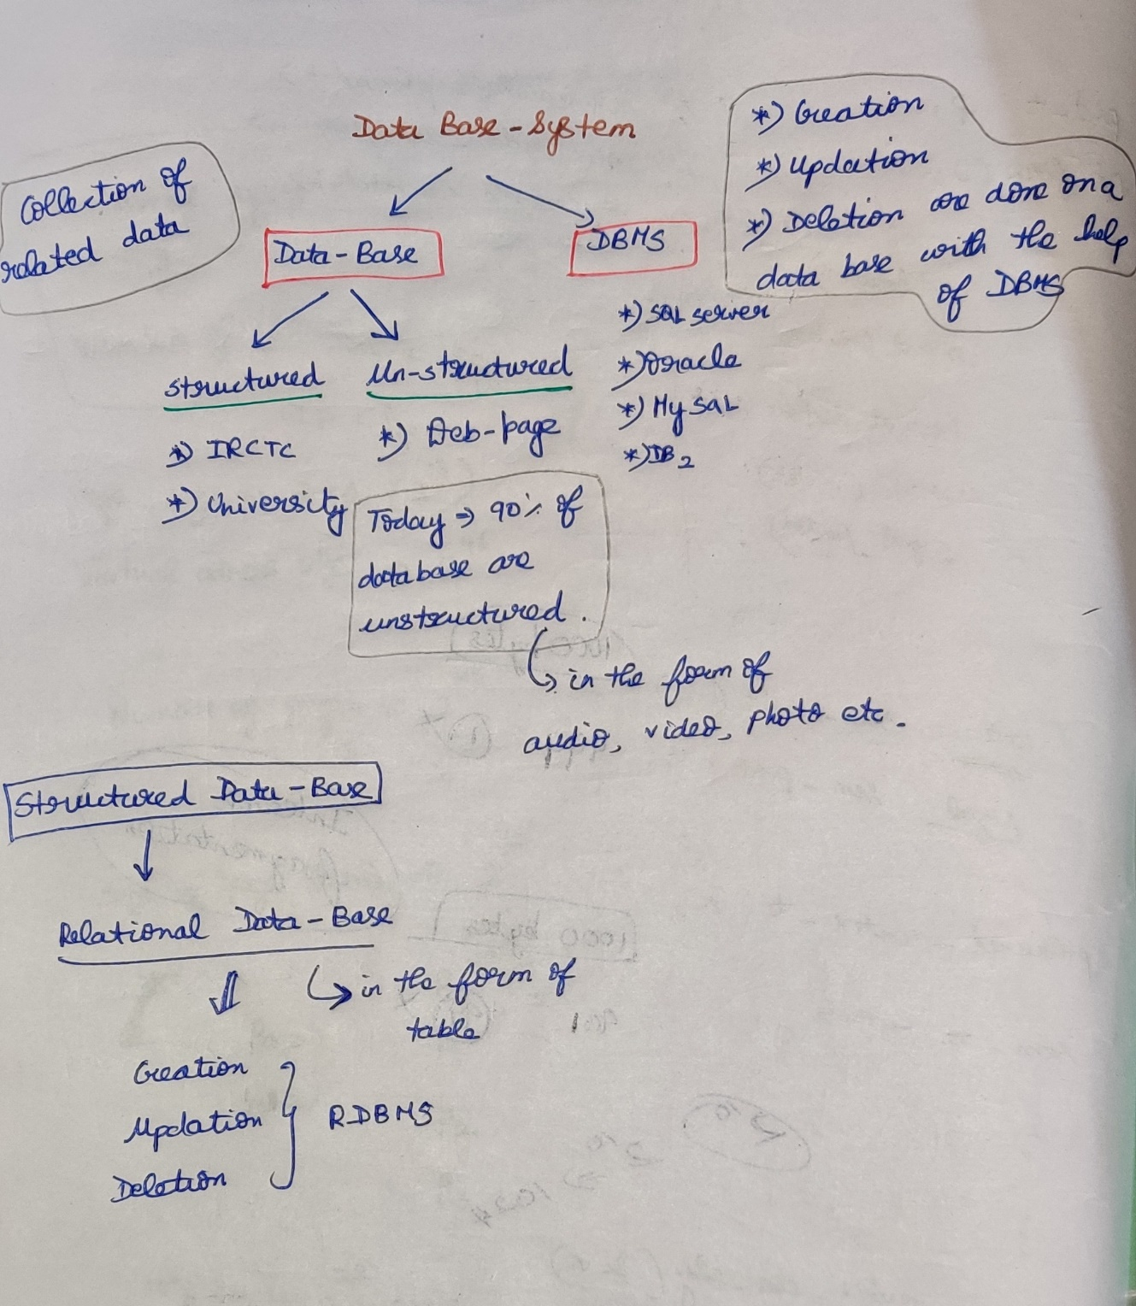

**File System (vs) DBMS**

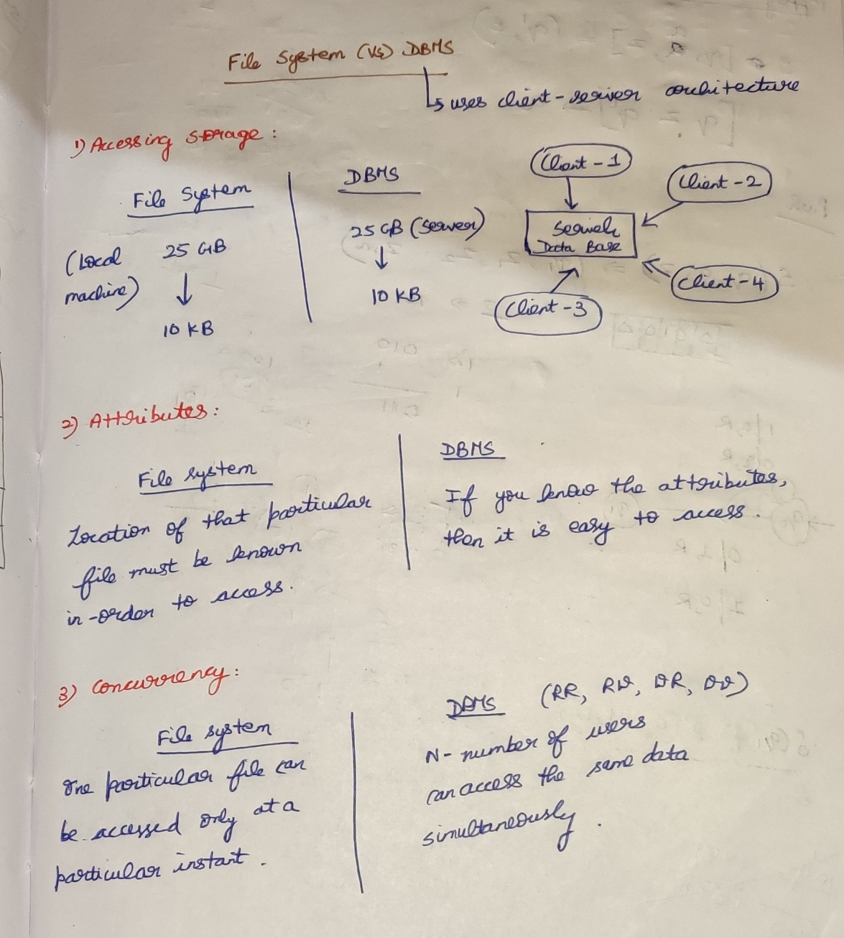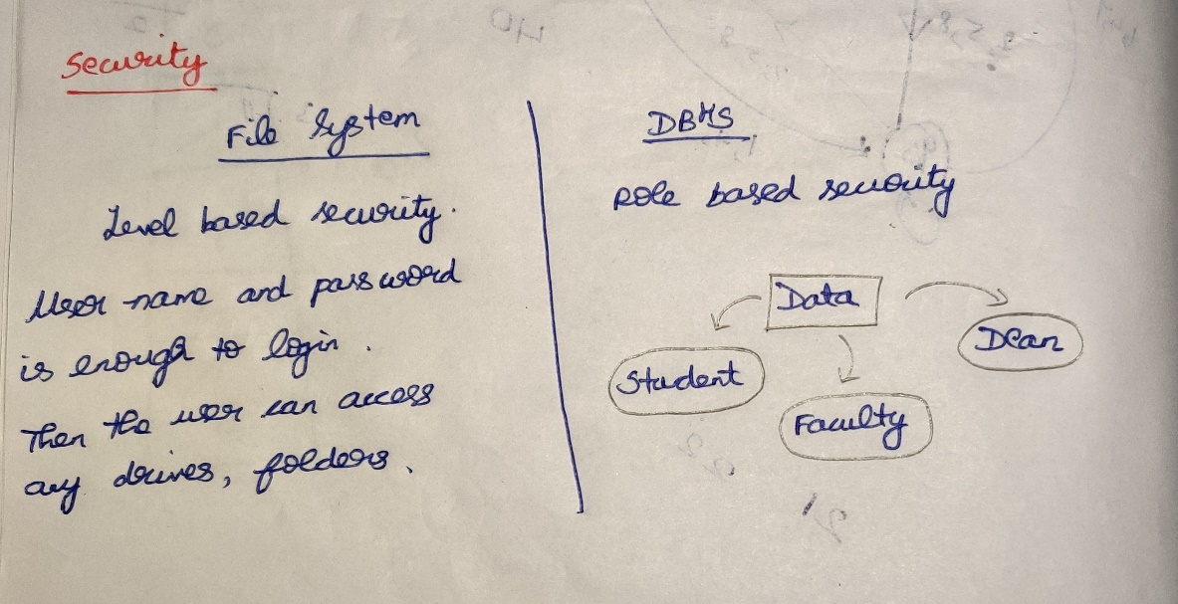

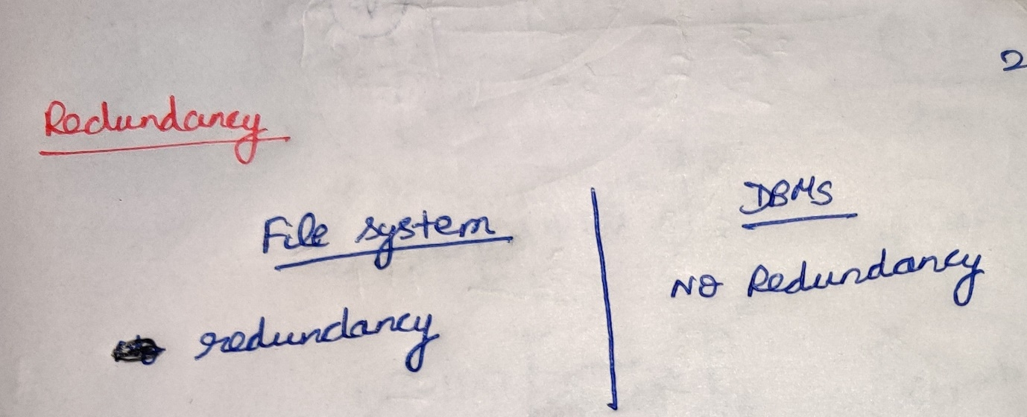

**3-schema Architecture**

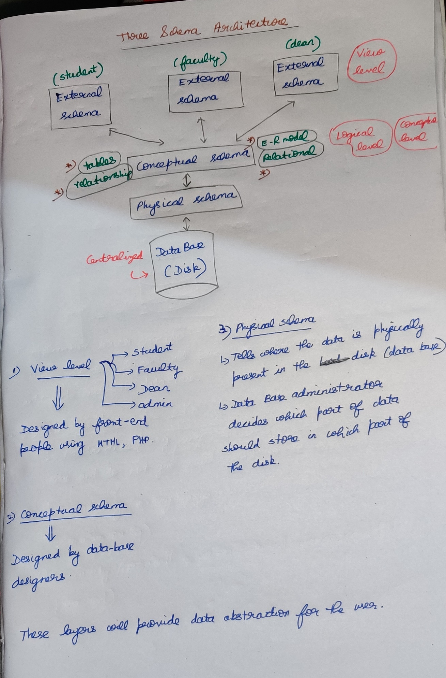

**2-tier and 3-tier Architecture**

**2-tier (Client Server Architecture)**

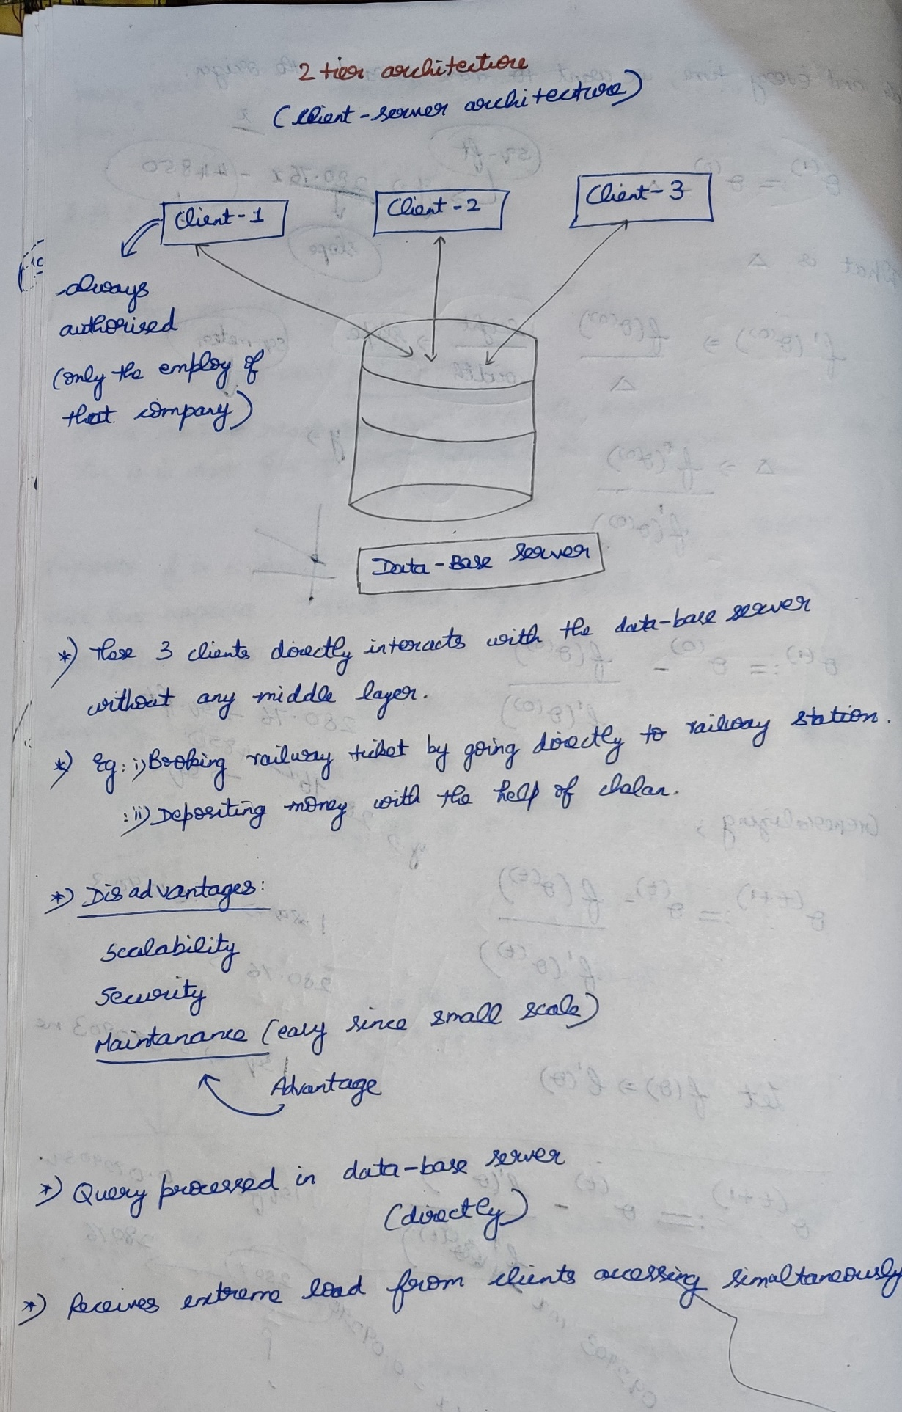

**3-tier (Client Application and Server Architecture)**

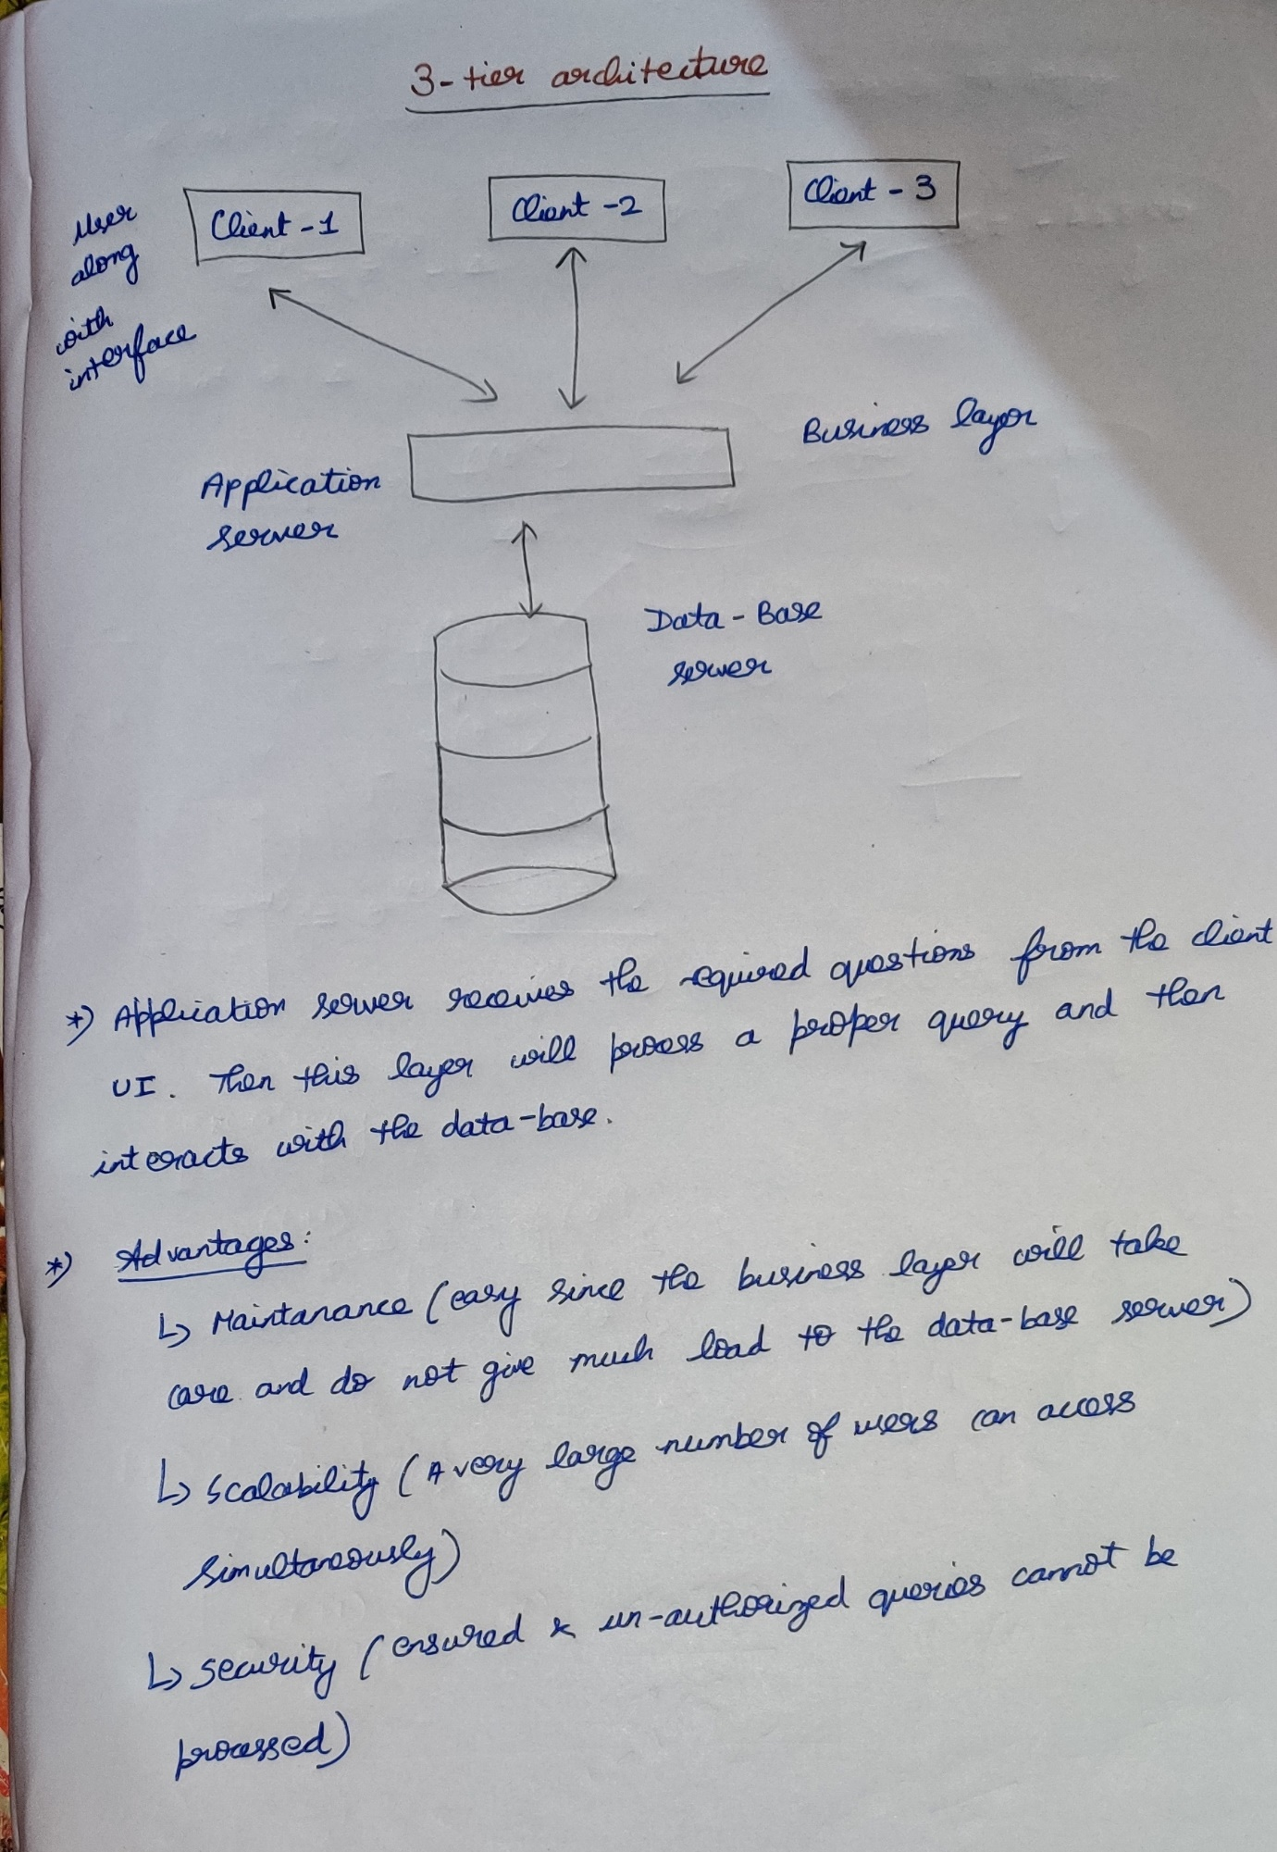

**Data Independence**

It is defined as the property of the DBMS that helps to change the data-base schema at one level of a database system without requiring to change the schema at the next higher level.

Candidate key 🡪

Primary key 🡪 (Unique + NOT NULL) 🡪 There will be only one primary key in a table.

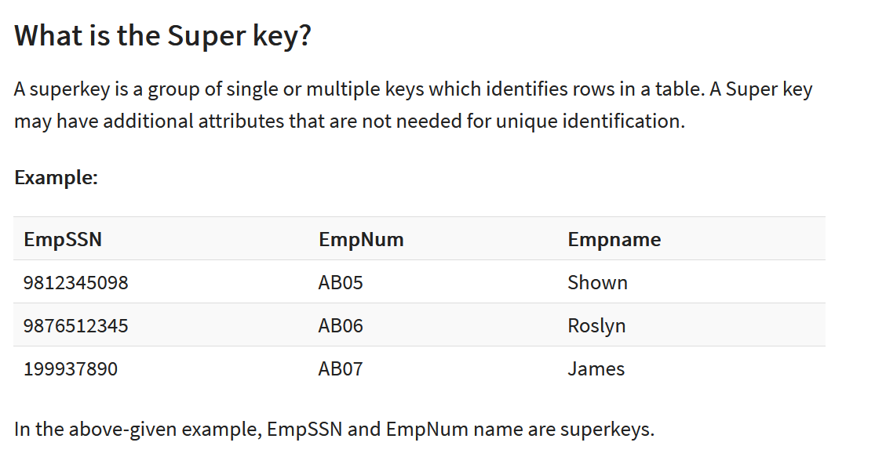

Minimal super key 🡪 Candidate key  
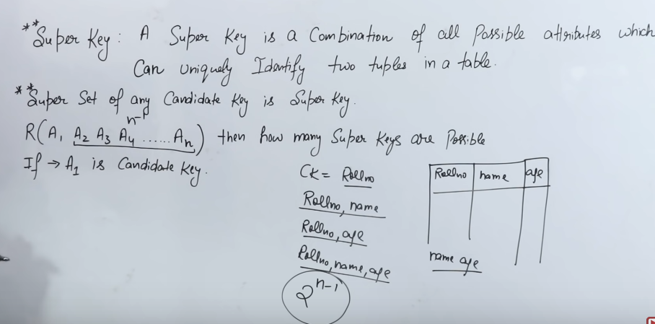



Super keys are possible



<https://www.geeksforgeeks.org/number-of-possible-superkeys-in-dbms/>

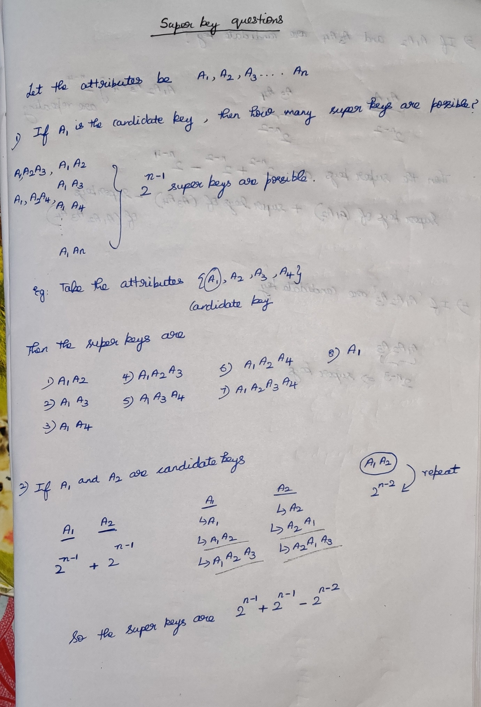

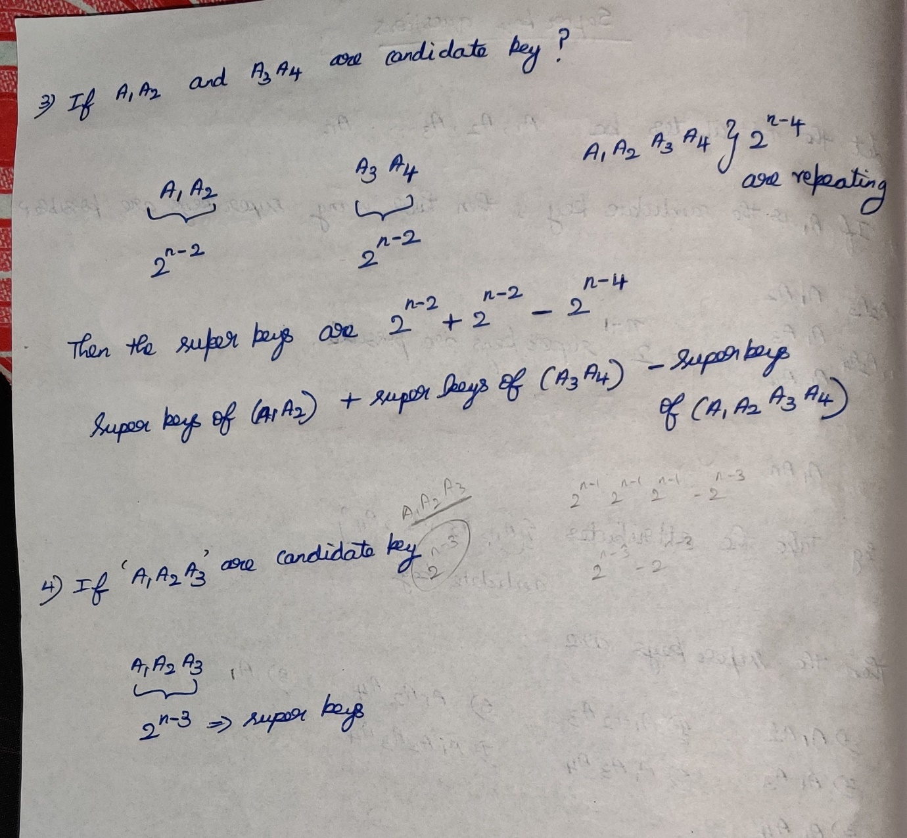

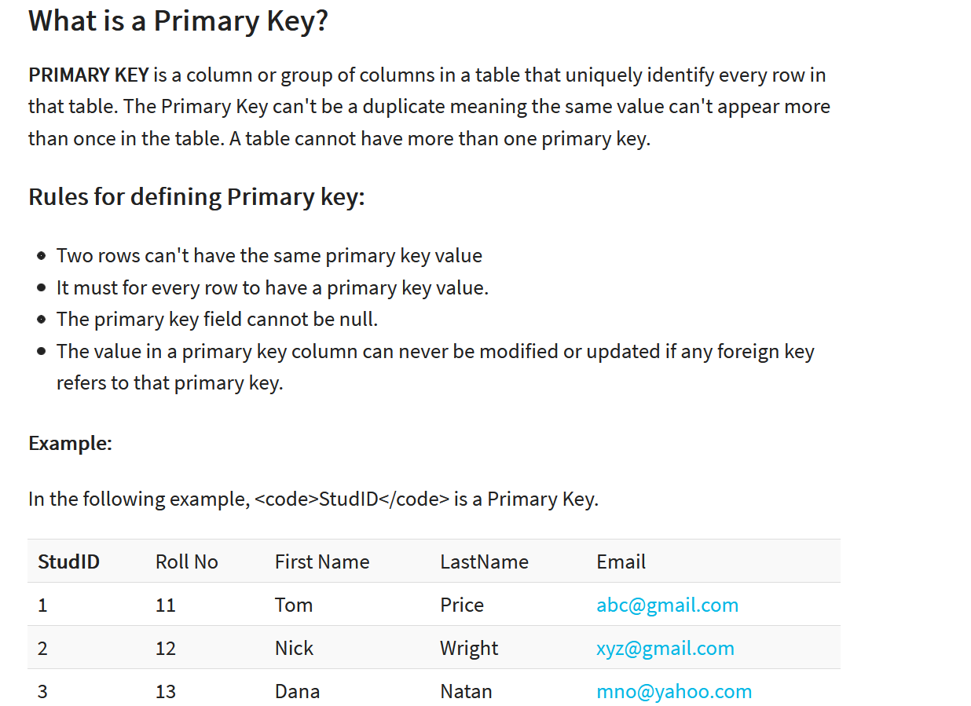

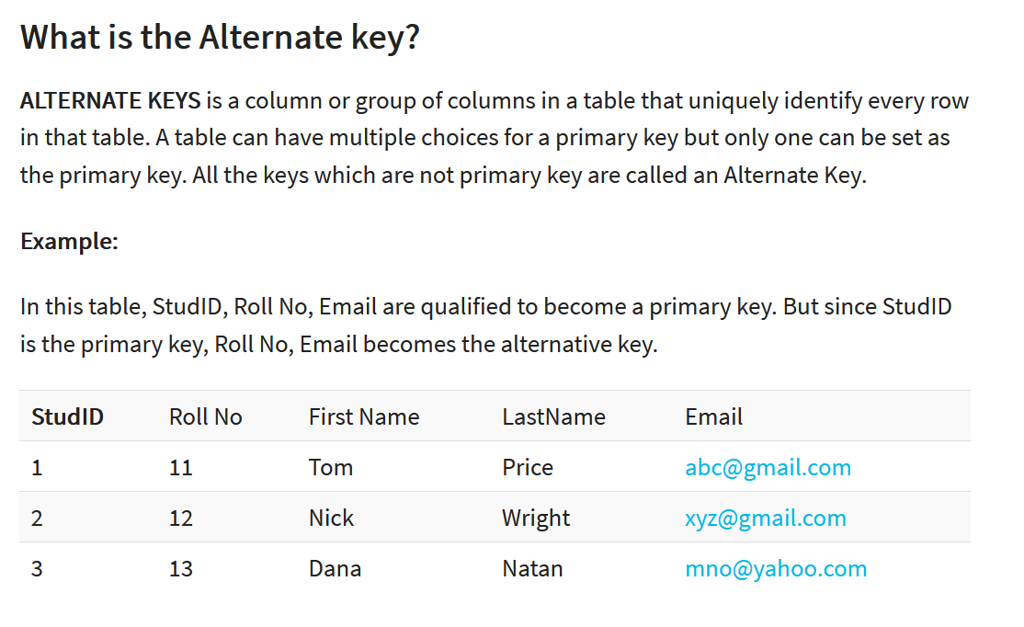

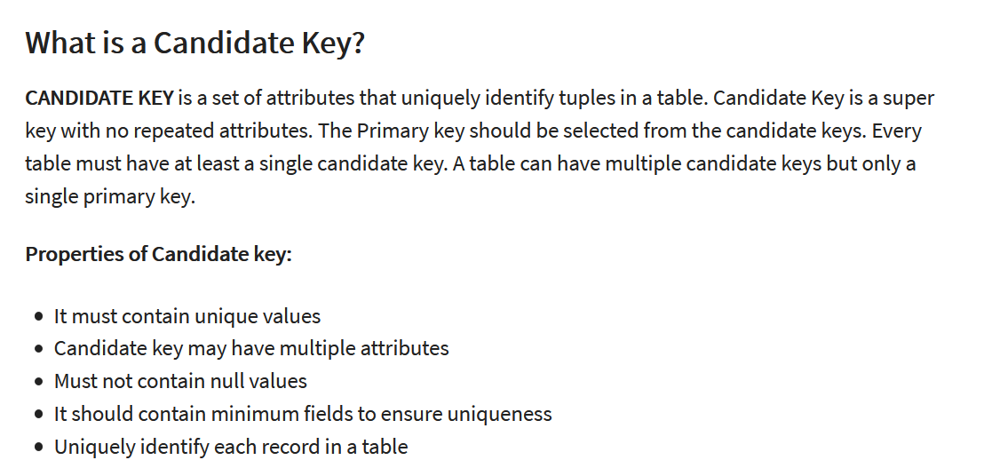  
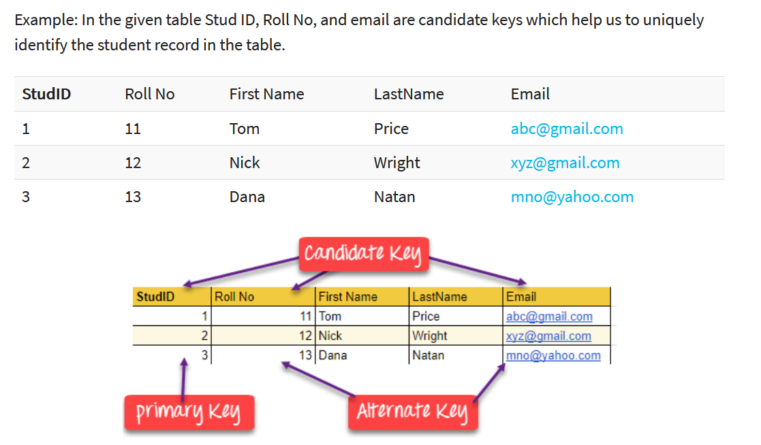

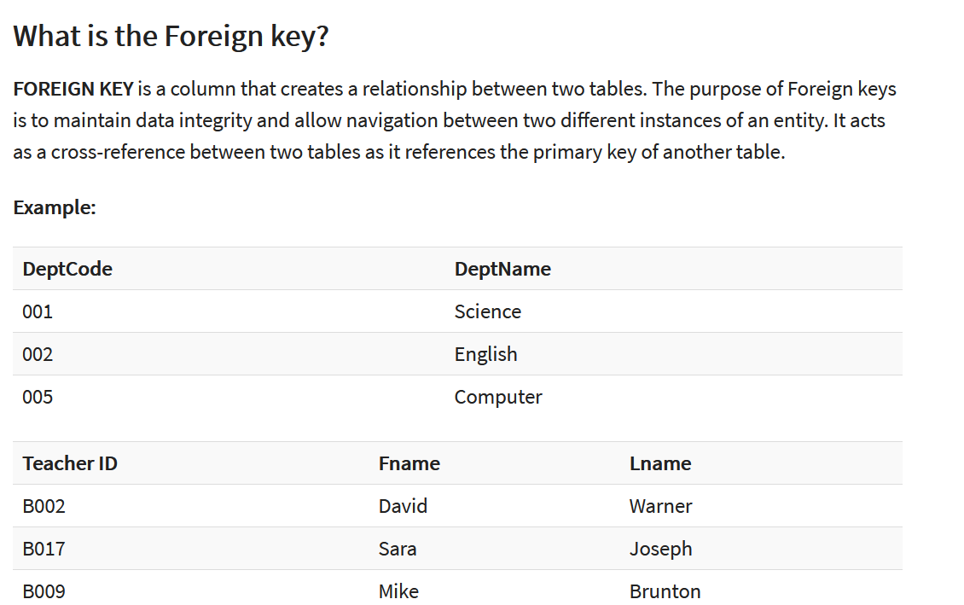  
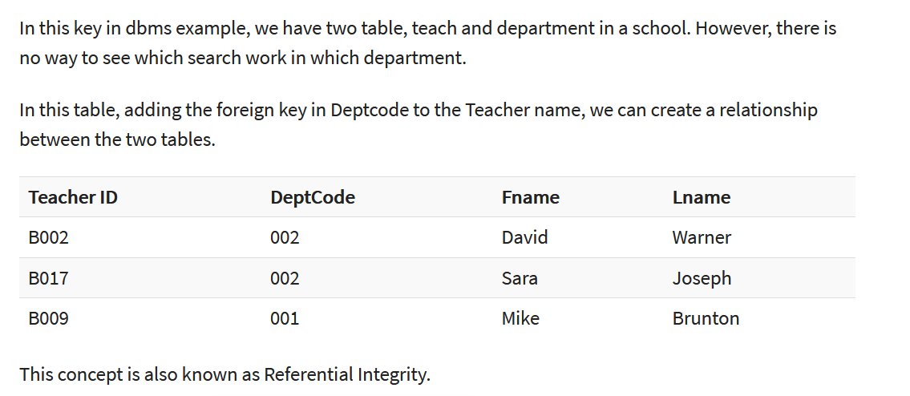

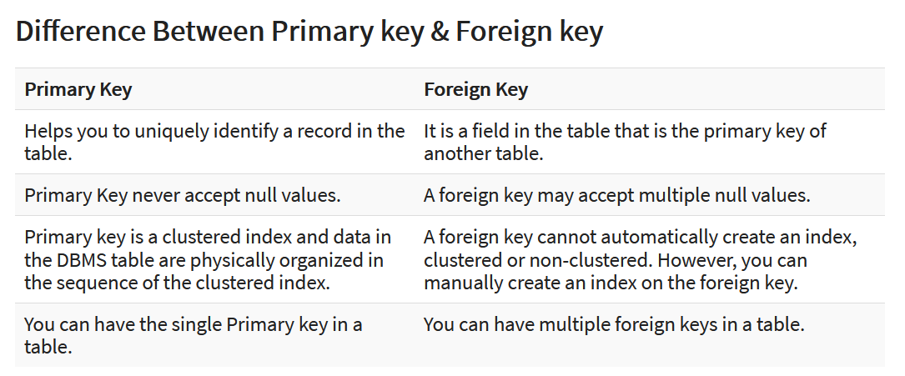

***Finding the number of super keys ????***

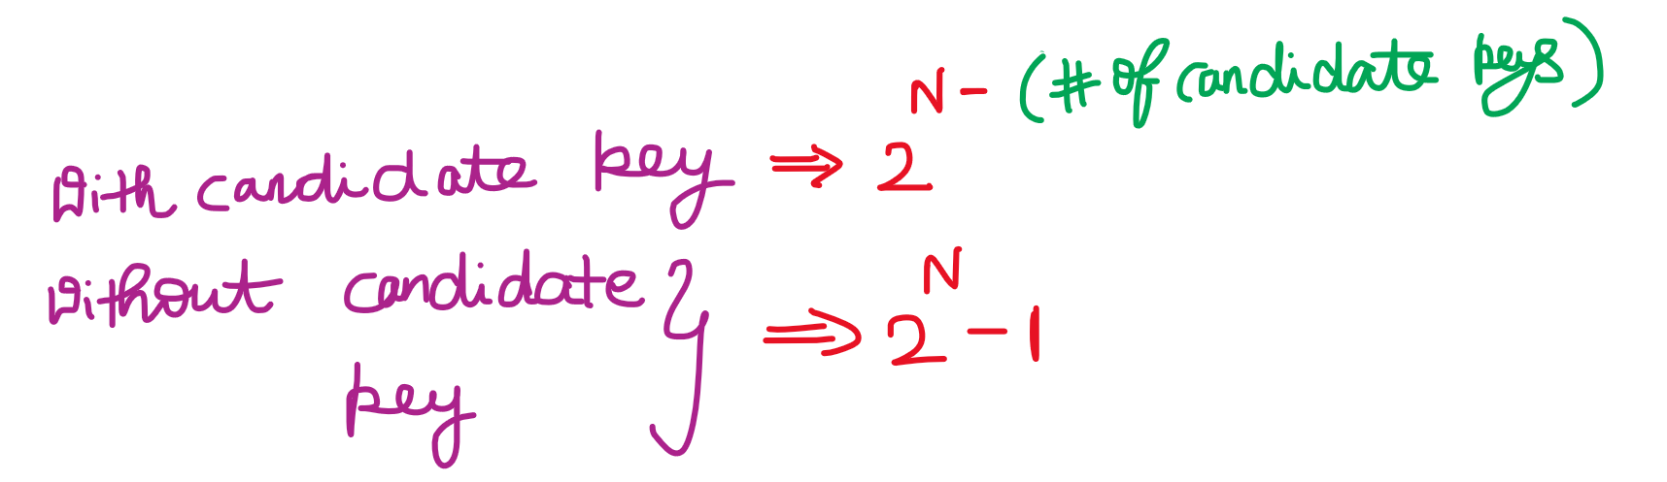

Link 🡪 <https://www.geeksforgeeks.org/number-of-possible-superkeys-in-dbms/>

